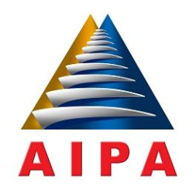

ASEAN INTER-PARLIAMENTARY ASSEMBLY

33RD GENERAL ASSEMBLY

16 – 22 SEPTEMBER 2012, LOMBOK, INDONESIA

MESSAGE BY SAMDECH AKKA MOHA SENA PADEI TECHO HUN SEN
PRIME MINISTER OF THE KINGDOM OF CAMBODIA

On behalf of ASEAN member state and the Royal Government of Cambodia, I would like to sincerely thank His Excellency Dr. H. Marzuki Alie for inviting me as the Chair of ASEAN to this important General Assembly. I would like to highly appreciate the organizing of the 33rd General Assembly, under the Theme of “Strengthening Parliamentar Roles toards ASEAN Community 2015”, which is very timely. On one hand, the meeting coincides with the 45th Anniversary of ASEAN, and on the other hand, it is conveyed amidst ASEANs ongoing effort towards building the ASEAN Community by 2015.

Despite the afore-mentoined great achievements, we have to recognize that ASEAN still continues to face many challenges globally and regionally. Global challenge include, among others, fragile economic recovery of developed countires coupled with prolonged det crisis in Europe, the ongoing social and political turmoil in the Middle East and North Africa, high oil prices, food and enery security, climate change, natural disasters, terrorism and international crime.

In addition to providing necessary supports for ASEAN, as the legislative institution representing the people, AIPA can also effectively convey the message to our people about what ASEAN has done for the benefit of our nations so as to inspire the spirit of “We Belonging to ASEAN”

. . . . .

